Programming document for complex:

**Day 1 (1/16/2023)**

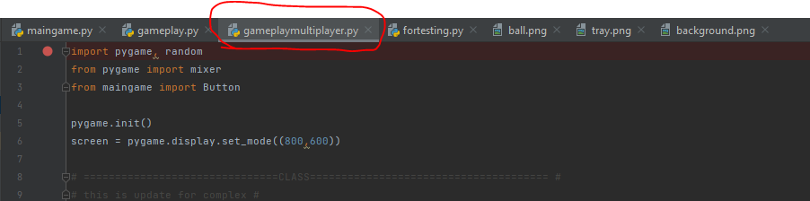

Figure 1:

The “gameplay.py” has changed to “gameplaymultiplayer.py”. The “gameplaysingleplayer.py” will be add soon.

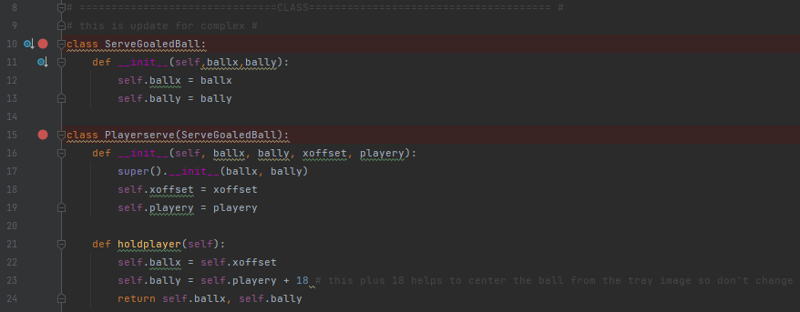

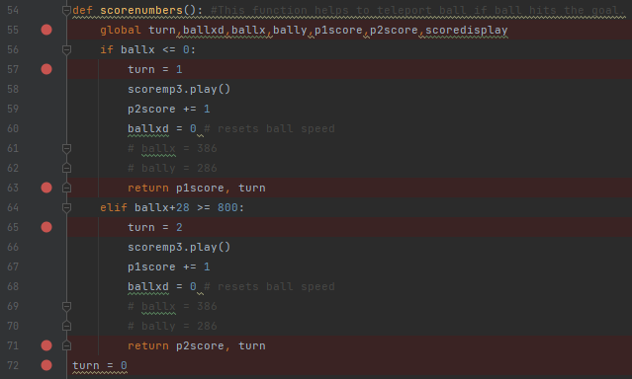

Figure 2.1:

Added classes, variable “turn”, and modify “scorenumber()” to function the player serving ball

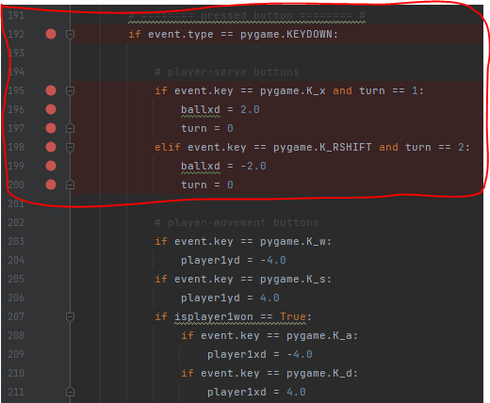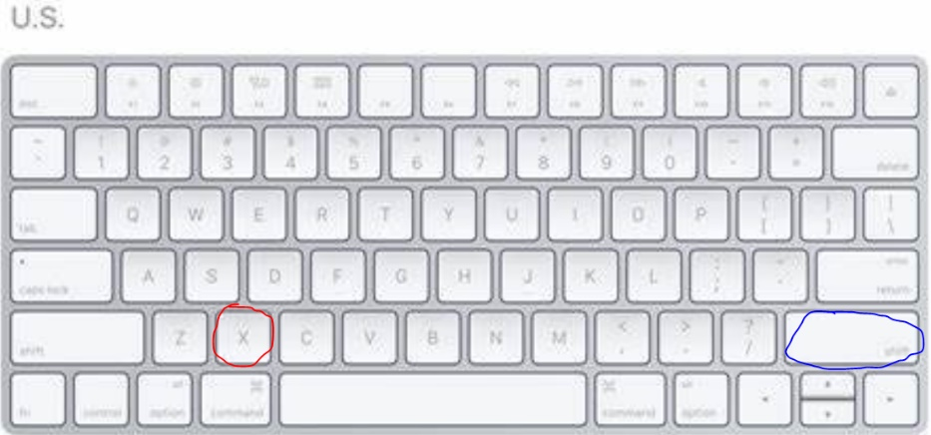

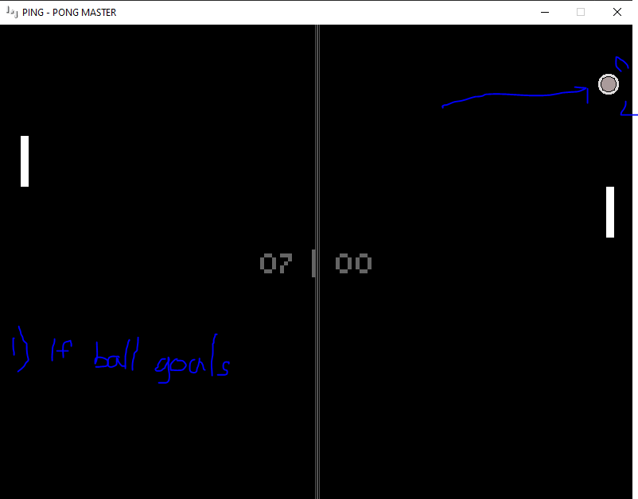

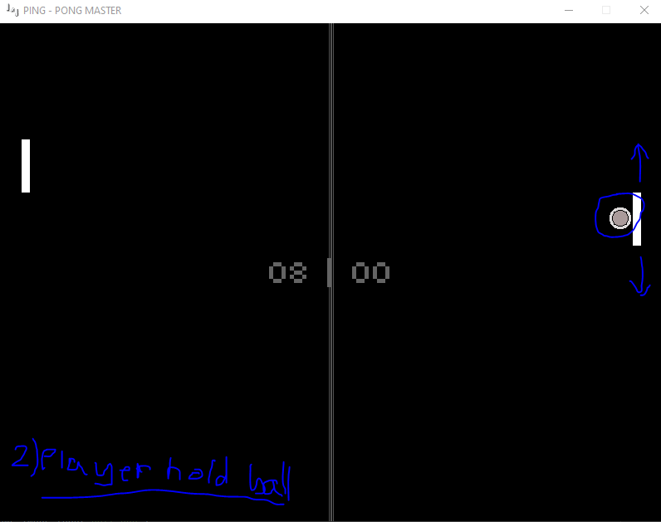

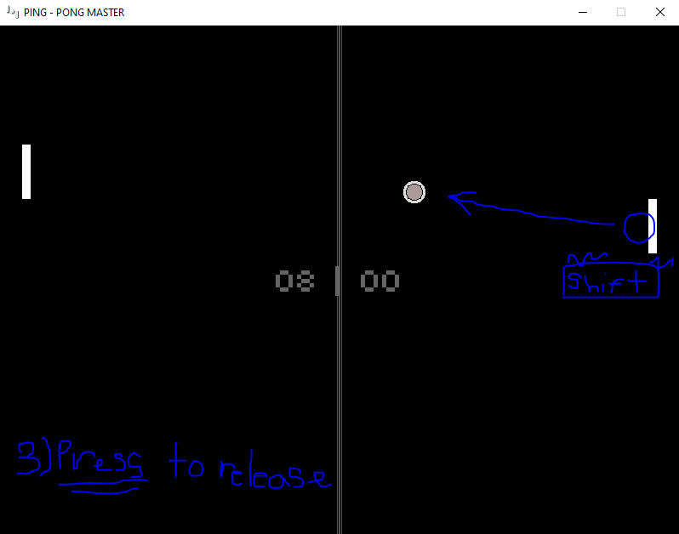

Figure 2.2:

Added buttons to release the serve ball for each player. “X” for player1; “Right Shift” for player2.

-if ball hit goals, the ball will teleport to the player, the ball is stuck to the player’s y coordinate.

-if pressed the release button, the player serves the ball.

Day 2 update: the player 1 serve ball button has changed “X” key to “Left Shift” key.

**Day 2 (1/17/2023)**

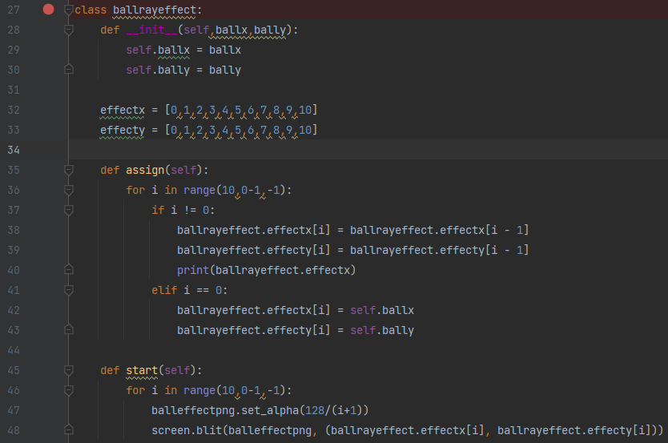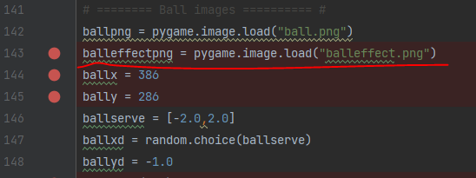

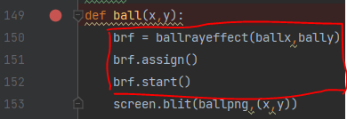 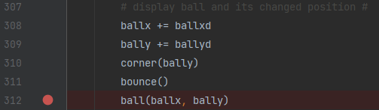

Figure 3.1:

Added classes and function “ball” with new image “balleffect.png” to create an trail effect of the ball.

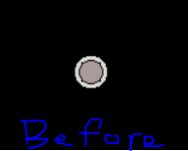 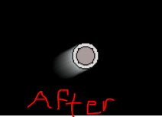

Figure 3.2:

The Trail effect of the ball.

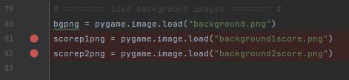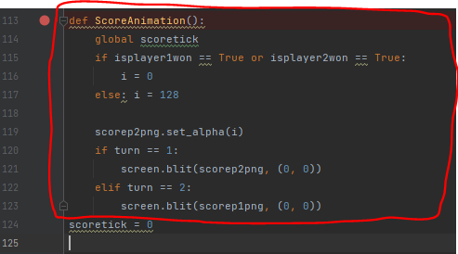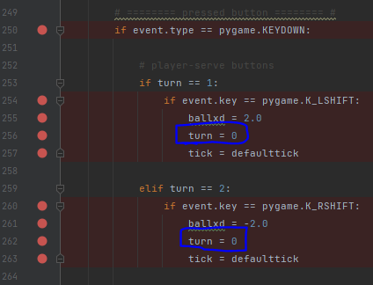

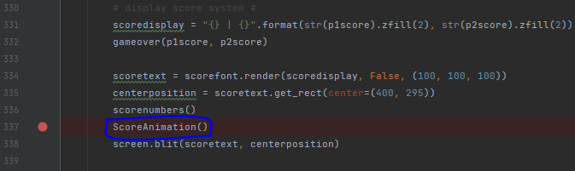

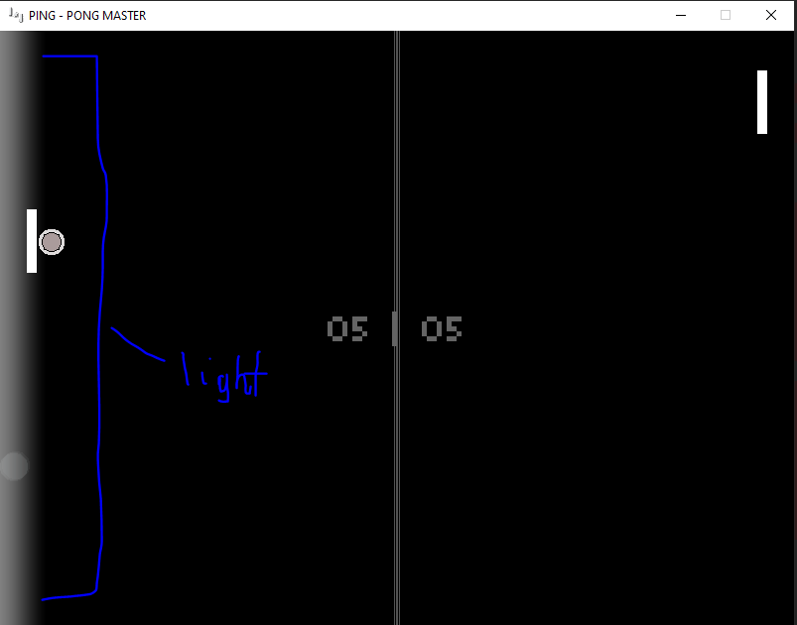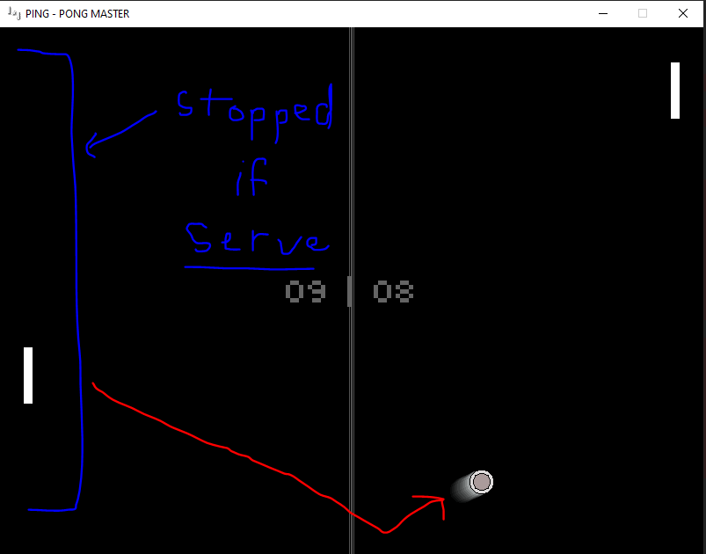

Figure 4:

Added Light on corners if opposing player scores the goal. This light animation will be stop if player is serving the ball.

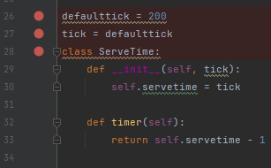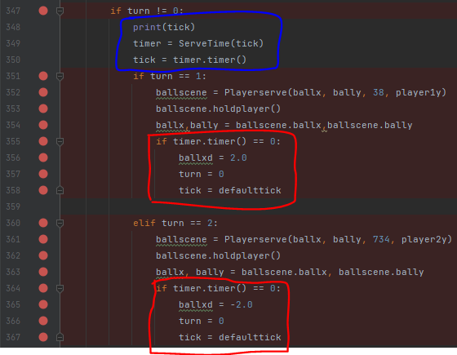  
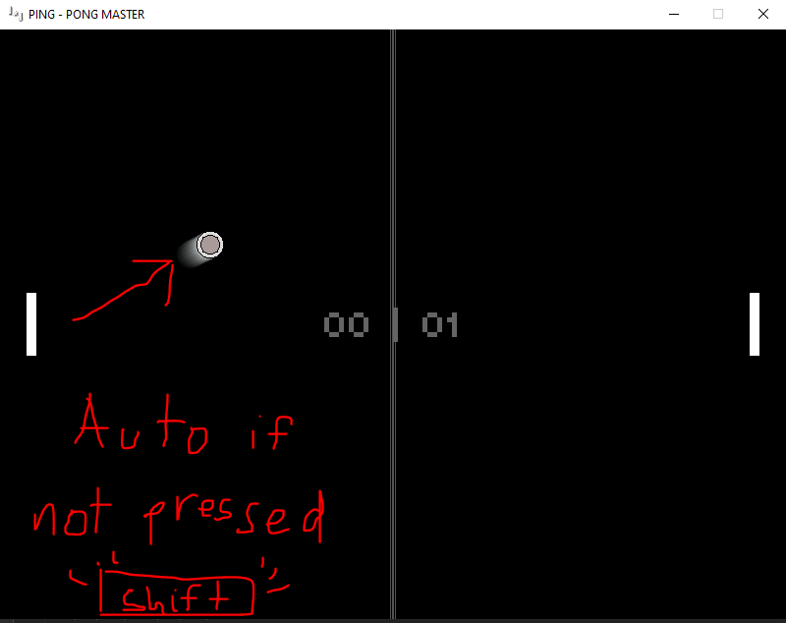

Figure 5:

Added a class “ServeTime()” to automatically released the serving ball if player does not click the serve key. (ex: 200 tick seconds is the limit, look at “defaulttick” on line 26)

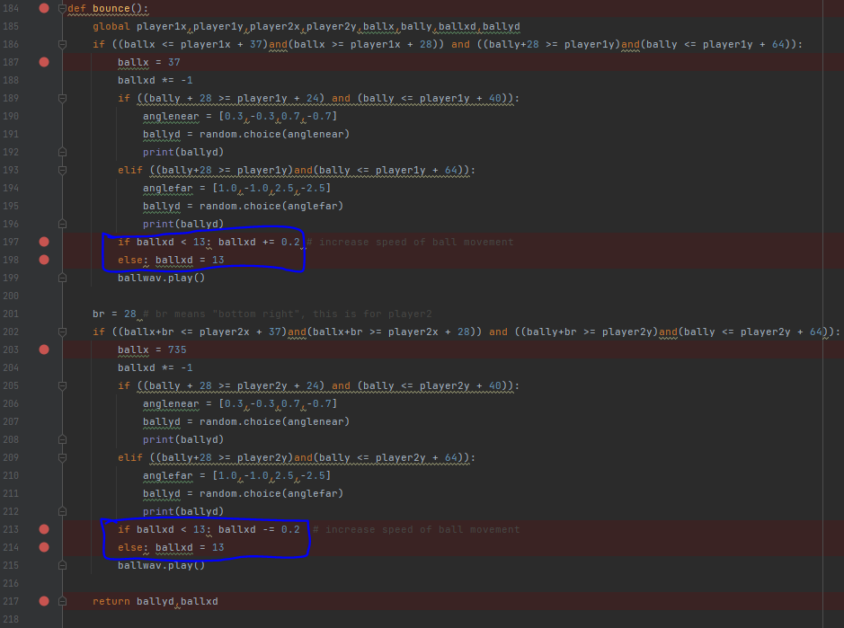

Figure 6:

Modified some lines on function “bounce()”. Added a functionality to limit ball speed in order to prevent blitzing the ball coordinate past player’s tray in case if the ball speed is too high.

That’s all for day 2 :/